Record No: 0638
SIR JAMES HERBERT GUSTAVIS MEREDYTH SOMERVILLE
2nd Baron Athlumney of Somerville, Balrath, Co Meath.

Eldest son of Sir William Meredyth Somerville (0598) and Maria Georgiana Elizabeth Jones (0601).

Birth: 23 Mar 1865, at Somerville
Bapt: 25 Apr 1865, Kentstown
Marriage: 30 July 1919, Margery Honor Boan
Death: 8 Jan 1929

Source: Somerville Index

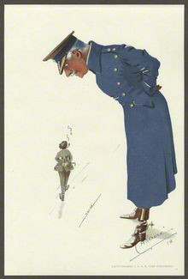
From: estate of Lester Howard Sacré /
National Portrait Gallery, London

Further Research:
James Somerville was educated at Harrow before entering the army.

1882 Lt. Prince of Wales Regiment
1886 Lt. Coldstream Guards
1890-96 Attached to the Egyptian Army
ADC to Lord Kitchener for 2 years
Orders of Osmanieh and Medjidieh
1896 Dongola Expedition (medal + 2 clasps)
1900 South Africa (medal + 4 clasps)

Lt Col. Coldstream Guards
Assistant Provost Marshal London District 1914-18

Dep.Lt.. Co Louth
ADC to Lord Lieutenant of Ireland
d.s.p

He sat in the House of Lords as Baron Meredyth.

Please see Obituary, funeral and memorial services and estate details published in The Times (below).
Note that his wife appears not to have attended either his funeral or memorial service.
Lord and Lady Athlumney appear regularly in the Court and Social pages of The Times between 1919 and 1929 recording their travels and movements, e.g.:
10 Oct 1919: Lord and Lady Athlumney have arrived in Dublin from Somerville, county Meath.
17 May 1920: Lord Athlumney has arrived in London from Somerville, Meath.
26 May 1920: Lord and Lady Athlumney have arrived at 12 Southwick Place Hyde Park, W, which they
have taken for the season. Telephone Pad. 3601
25 June 1920: A description of Lady Athlumney’s dress at Court for presentation of Debutantes
20 Dec 1921: Lord and Lady Athlumney have sailed for the West Indes. They expect to be away about
three months.
21 Mar 1922: Lord and Lady Athlumney have just arrived in London from Jamaica.

He left estate valued at £5789, the equivalent of £273,000 today. http://www.measuringworth.com/calculators/ukcompare/result.php
See also, visit to New York: http://query.nytimes.com/mem/archive-free/pdf?res=F50715FE3A5A17738DDDA10994D9415B888CF1D3

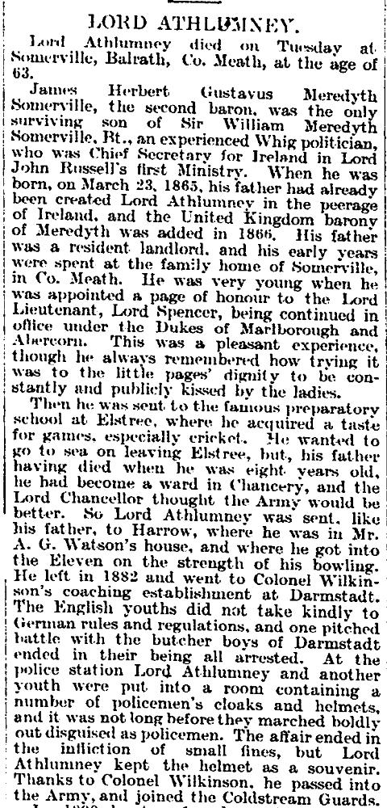
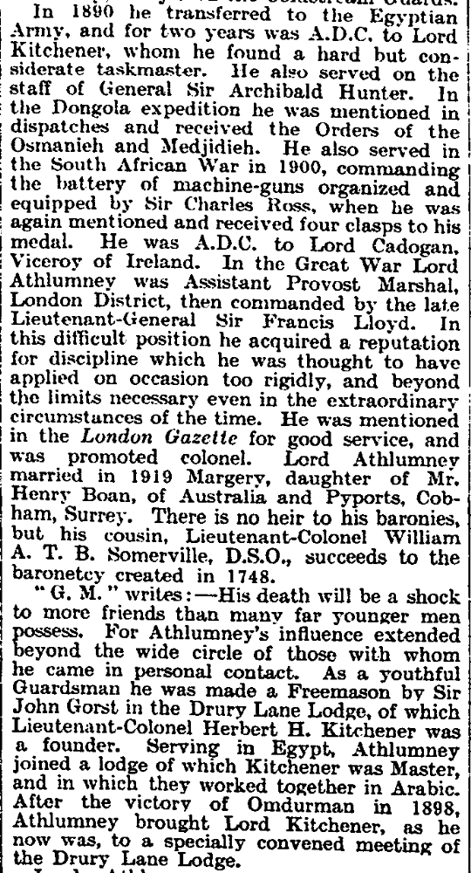
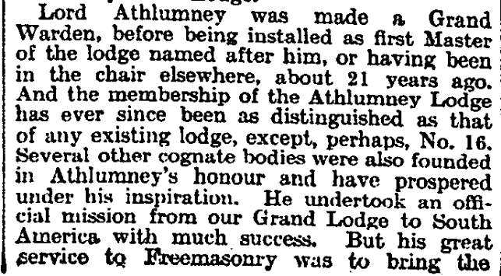
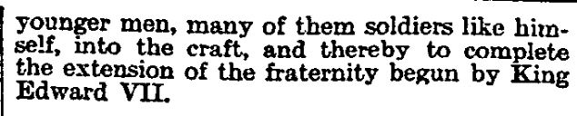
The Times Thur 10 Jan 1929

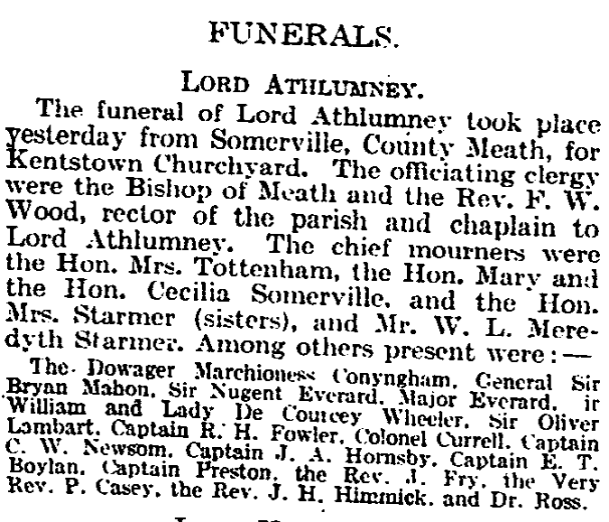
The Times 11 Jan 1929

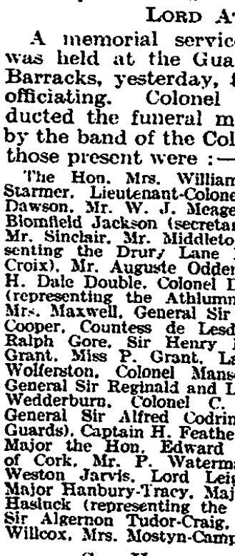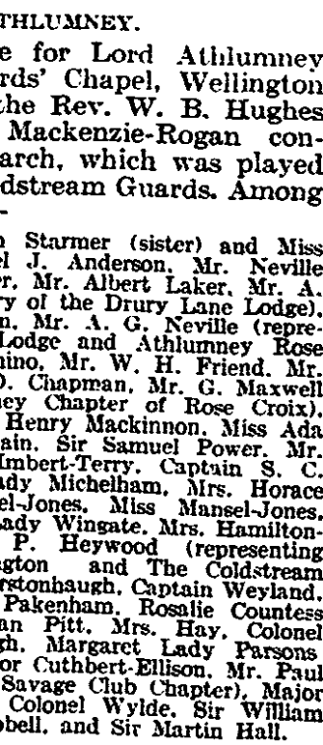
The Times Tues 15 Jan 1929
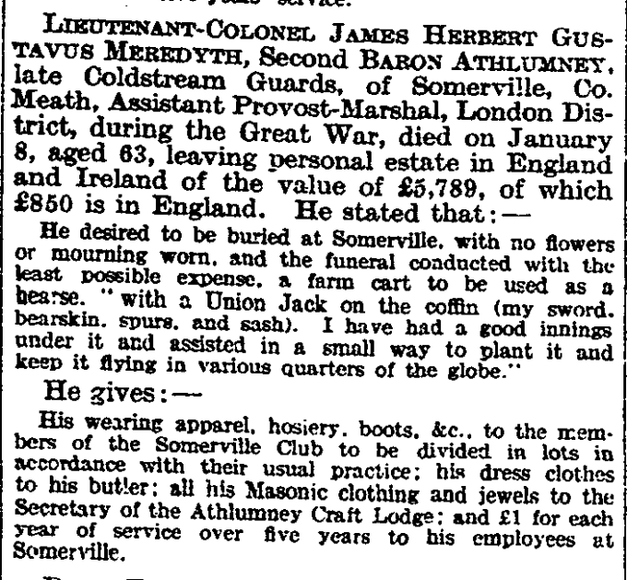
The Times 5 Dec 1929

